# Baldivis Secondary College



### Semester Two Examination, 2017

### Question/Answer booklet

# MATHEMATICS

If required by your examination administrator, please place your student identification label in this box

**METHODS**

**UNITS 3 AND 4**

## Section One:

## Calculator-free

|  |  |  |  |  |  |  |  |  |  |  |
| --- | --- | --- | --- | --- | --- | --- | --- | --- | --- | --- |
| Student Number: In figures |  |  |  |  |  |  |  |  |  |  |

In words

Your name

## Time allowed for this section

Reading time before commencing work: five minutes

Working time: fifty minutes

## Materials required/recommended for this section

***To be provided by the supervisor***

This Question/Answer booklet

Formula sheet

***To be provided by the candidate***

Standard items: pens (blue/black preferred), pencils (including coloured), sharpener, correction fluid/tape, eraser, ruler, highlighters

Special items: nil

## Important note to candidates

No other items may be taken into the examination room. It is **your** responsibility to ensure that you do not have any unauthorised material. If you have any unauthorised material with you, hand it to the supervisor **before** reading any further.

## Structure of this paper

|  |  |  |  |  |  |
| --- | --- | --- | --- | --- | --- |
| Section | Number of questions available | Number of questions to be answered | Working  time (minutes) | Marks available | Percentage of examination |
| Section One:  Calculator-free | 8 | 8 | 50 | 52 | 35 |
| Section Two:  Calculator-assumed | 13 | 13 | 100 | 97 | 65 |
|  | | |  | **Total** | 100 |

|  |  |  |
| --- | --- | --- |
| Markers use only | | |
| Question | Maximum | Mark |
| 1 | 6 |  |
| 2 | 6 |  |
| 3 | 7 |  |
| 4 | 7 |  |
| 5 | 6 |  |
| 6 | 8 |  |
| 7 | 7 |  |
| 8 | 5 |  |
| S1 Total | 52 |  |
| S1 Wt (×0.6731) | 35% |  |
| S2 Wt | 65% |  |
| Total | 100% |  |

## Instructions to candidates

1. The rules for the conduct of examinations are detailed in the school handbook. Sitting this examination implies that you agree to abide by these rules.

2. Write your answers in this Question/Answer booklet.

3. You must be careful to confine your response to the specific question asked and to follow any instructions that are specified to a particular question.

4. Additional working space pages at the end of this Question/Answer booklet are for planning or continuing an answer. If you use these pages, indicate at the original answer, the page number it is planned/continued on and write the question number being planned/continued on the additional working space page.

5. Show all your working clearly. Your working should be in sufficient detail to allow your answers to be checked readily and for marks to be awarded for reasoning. Incorrect answers given without supporting reasoning cannot be allocated any marks. For any question or part question worth more than two marks, valid working or justification is required to receive full marks. If you repeat any question, ensure that you cancel the answer you do not wish to have marked.

6. It is recommended that you do not use pencil, except in diagrams.

7. The Formula sheet is not to be handed in with your Question/Answer booklet.

Section One: Calculator-free 35% (52 Marks)

This section has**eight (****8)** questions. Answer **all** questions. Write your answers in the spaces provided.

Working time: 50 minutes.

Question 1 (6 marks)

The discrete random variable $X$ is defined by

$$P\left(X=x\right)=\left\{\begin{matrix}\frac{k}{2x+1} & x=0, 1 \\ & \\ 0 & \text{elsewhere.}\end{matrix}\right.$$

(a) Determine the value of the constant $k$. (2 marks)

(b) Determine

(i) $E{(7-4X)}$. (2 marks)

(ii) $\operatorname{Var}{(5+4X)}$. (2 marks)

Question 2 (6 marks)

(a) Determine $k$, if $2\log_{4}{6}-\log_{4}{3}+1=\log_{4}{k}$. (3 marks)

(b) Determine the exact solution to $3{\left(4\right)}^{x-1}=18$. (3 marks)

Question 3 (7 marks)

The rate of change of displacement of a particle moving in a straight line at any time $t$ seconds is given by

$$\frac{dx}{dt}={3e}^{0.1t}+5 \text{cm/s}.$$

Initially, when $t=0$, the particle is at $O$, a fixed point on the line.

(a) Calculate the initial velocity of the particle. (1 mark)

(b) Determine the distance of the particle from $O$ after $30$ seconds. (3 marks)

(c) Determine when the acceleration of the particle is $6 {\text{cm/s}}^{2}$. (3 marks)

Question 4 (7 marks)

The graph of $y=f\left(x\right), x≥0$, is shown below, where $f\left(x\right)=\begin{matrix}4x \\ \overline{x^{2}+3}\end{matrix}$.

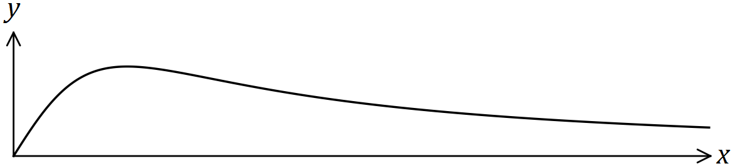

(a) Determine the gradient of the curve when $x=2$. (3 marks)

(b) Determine the exact area bounded by the curve $y=f(x)$ and the lines $y=0$ and $x=2$, simplifying your answer. (4 marks)

Question 5 (6 marks)

The functions $f$ and $g$ intersect at the point $(3, -5)$.

The first derivatives of the functions are $f^{'}\left(x\right)=18{\left(7-3x\right)}^{2}$ and $g^{'}\left(x\right)=6π\cos\left(\frac{πx}{2}\right)$.

Determine an expression for each function.

Question 6 (8 marks)

A curve has first derivative $\begin{matrix}dy \\ \overline{dx}\end{matrix}=3x(x-4)$ and passes through the point $P(1, -5)$.

(a) Determine the value(s) of $x$ for which $\begin{matrix}d^{2}y \\ \overline{dx^{2}}\end{matrix}=0$. (2 marks)

(b) Sketch the curve on the axes below, clearly indicating the location of all axes intercepts, stationary points and points of inflection. (6 marks)

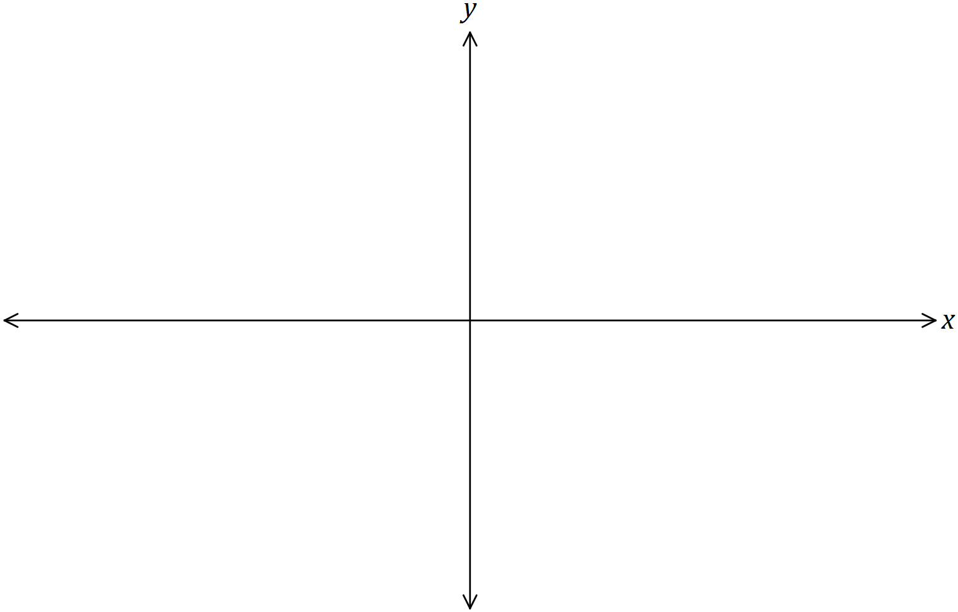

Question 7 (7 marks)

A function is defined by $f\left(x\right)=\begin{matrix}3+3\ln{x} \\ \overline{ 4x }\end{matrix}$.

(a) State the natural domain of $f$. (1 mark)

(b) Show that $f^{'}\left(1\right)=0$. (3 marks)

(c) Use the second derivative test to determine the nature of the stationary point of the function at $x=1$. (3 marks)

Question 8 (5 marks)

Part of the graph of the linear function $y=f(t)$ is shown below.

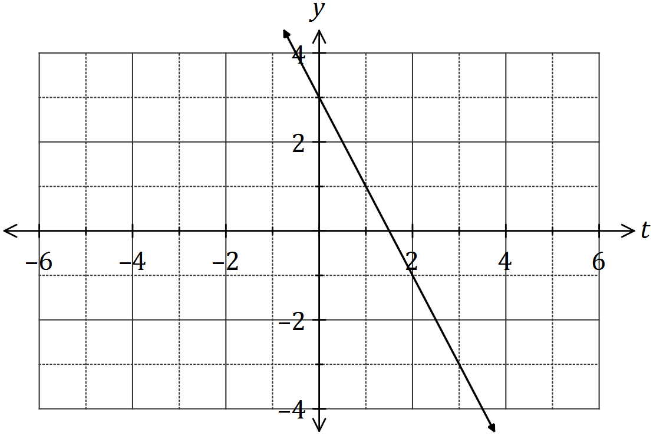

Another function $A(x)$ is given by

$$A\left(x\right)=\int_{1}^{x}{f(t)}dt .$$

Use the increments formula to estimate the change in $A$ as $x$ increases from $8.5$ to $8.6$.

Additional working space

Question number: _________

© 2017 WA Exam Papers. Baldivis Secondary College has a non-exclusive licence to copy and communicate this document for non-commercial, educational use within the school. No other copying, communication or use is permitted without the express written permission of WA Exam Papers. SN261-105-1.